Customer Research Findings: Example Answer

1. Introduction
This report summarises the findings from a customer survey and an observational study conducted to understand user experiences with Lloyds' digital banking services. The objective is to gather insights into customer satisfaction, ease of use, feature usage, and desired improvements.

2. Survey Results
The survey collected responses from 50 participants, focusing on their overall satisfaction, ease of use, and feature preferences.
Overall Satisfaction: {'Good': 26, 'Excellent': 10, 'Average': 9, 'Poor': 5}
Ease of Use: {'Easy': 37, 'Difficult': 7, 'Moderate': 6}
Most-Used Features: {'Balance Checking': 18, 'Money Transfers': 14, 'Bill Payments': 9, 'Others': 9}
Desired New Features: {'Others': 17, 'Budgeting Tools': 12, 'Detailed Spending Reports': 11, 'Spending Categorisation': 10}

Visualisations
The following charts illustrate the survey findings:
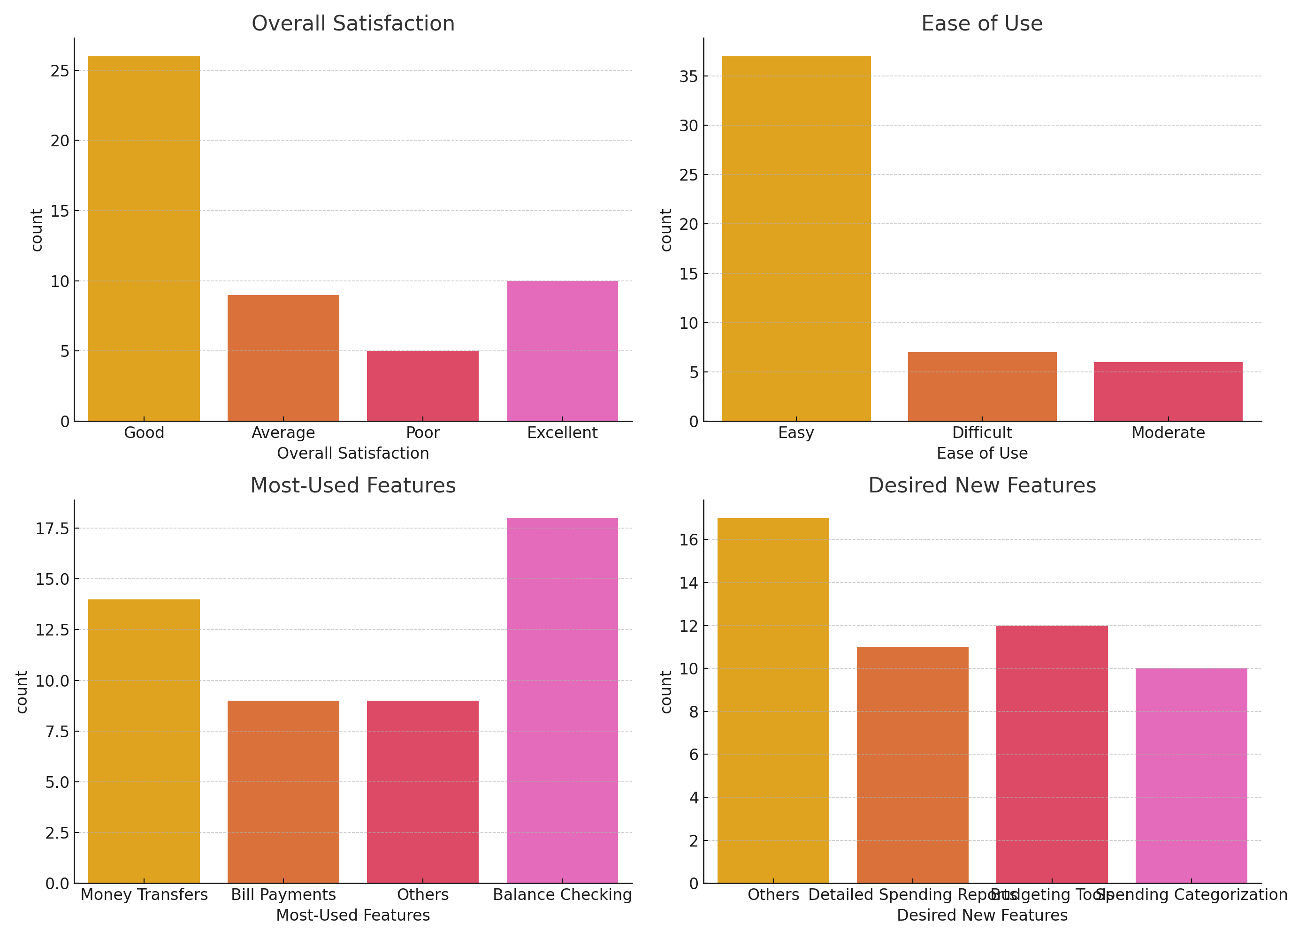

3. Observational Study Findings
Observations were made while users interacted with Lloyds' mobile app, focusing on common tasks such as checking account balances and making payments. Key findings include:
- Most users navigated the app smoothly, but some had difficulty locating the money transfer option.
- Delays during login were noted, causing frustration. Users expressed a need for more visible security features.
- Positive feedback was received on the app's clean design and quick access to balance information.

4. Recommendations
Based on the survey and observational study, the following recommendations are made to enhance user experience:
- Improve navigation by adding clearer icons and labels for key features like money transfers.
- Implement additional security measures, such as two-factor authentication, to boost user confidence.
- Develop tools for spending categorisation and detailed spending reports, which are highly requested by users.

5. Conclusion
The findings from this research highlight key areas for improvement in Lloyds' digital banking services. By addressing the identified challenges and implementing the recommended features, Lloyds can enhance user satisfaction and maintain a competitive edge in the market.

